**YALA – Yet Another List App**

User Guide

Account Management

**Create Account**

1. Press “Get Started”
2. Press “Create Account”
3. Fill out your username, email, and password. Do not use the same email multiple times, but your username and password can be anything.



1. Press “Submit”
2. You will now be at the logged in page with your new account

**Logging In**

1. Press get started

1. Press “Login”

1. Fill out your email and password information

1. Click submit
2. If you have created an account, you will then be logged in



**Logging Out**

1. Press “My Account”
2. Press “Logout”

1. You will then be back at the “Get Started” entry page

List Modification



**Creating a List**

1. Select “Add a List”



1. Graphical user interface, text, application, chat or text message

   Description automatically generatedFill out your list name
2. Graphical user interface, text, application, chat or text message

   Description automatically generatedClick “Submit”
3. Your empty, new list will now appear



**Deleting a List**

1. Select “Delete a List”
2. Select the list you would like to delete

1. Graphical user interface, text, application, chat or text message

   Description automatically generatedConfirm that you would like to delete the list by clicking “Yes”
2. The list you chose will now no longer appear in your lists



**Duplicating a List**

1. Select “Duplicate a List”



1. Enter the name you want to call the new list



1. Click the list that you would like to duplicate



1. The new list will now be displayed



Item Lookup

**Finding a Store**



1. Press “Search Items



1. You can now view the stores, and click on the store you want to see its items

**Searching for an Item**

**Adding an Item**

1. Press the store you would like to add an item from

1. If you do not see the item you want, press “Filter” in the top left

1. Use the filter to narrow down the options, since we are looking for wheat bread, we hover over bread, and then press “wheat”

1. The results will now be narrowed down

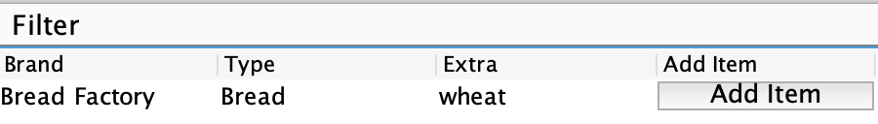

1. Graphical user interface, text, application

   Description automatically generatedPress “Add Item” in the row of the item that you would like to add to your list
2. Click on the list that you would like to add the item to, and edit the quantity if you want it to be more than one

1. Press “Add Item”
2. The item will now be added to the list you selected

Items Modification

**Crossing Off an Item**



1. Select a list

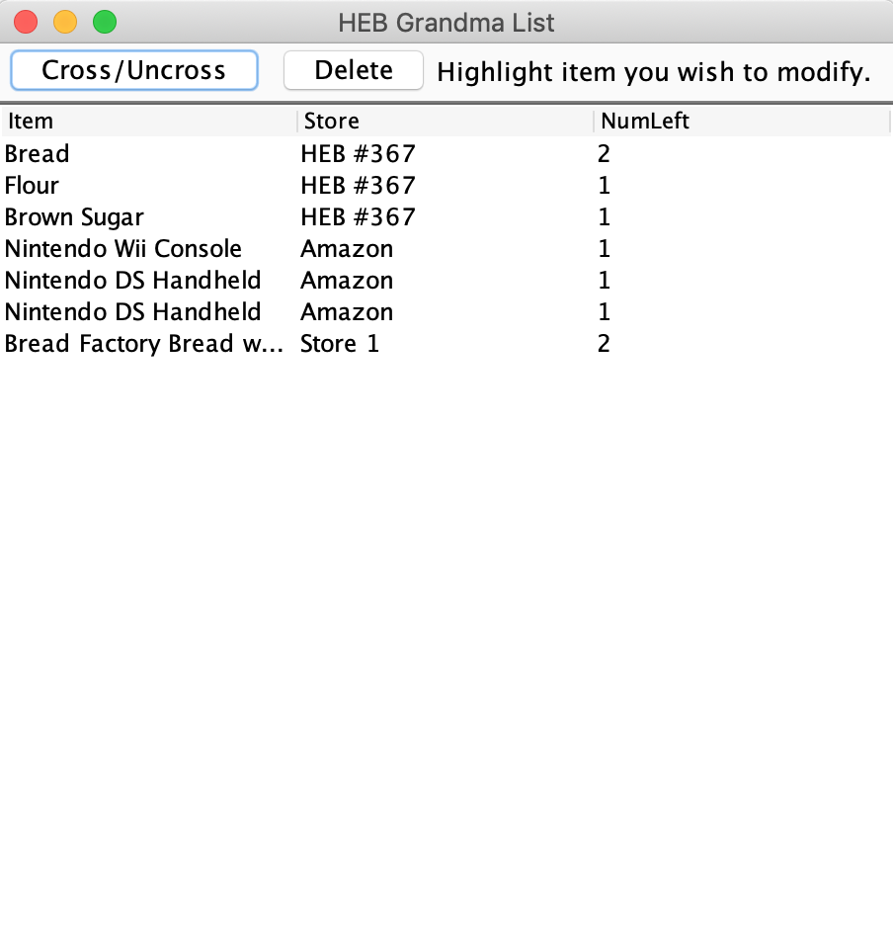

1. Select an item that you would like to cross off so that its row is highlighted

1. Select “Cross/Uncross”

1. Your item will now be shown as “Complete (X in cart)

**Uncrossing an Item**



1. Select a list

1. Select the item that you would like to uncross

1. Select “Cross/Uncross”

1. Your item will now be uncrossed off and removed from your cart

**Deleting an Item**



1. Select a list

1. Select the item you would like to delete from the list

1. Press “Delete”

1. Confirm that you want to delete the item by pressing “Yes”
2. The item will now be removed from your list

Getting Help in App

1. Press “Help” in the top left corner
2. Hover over the menu option that corresponds to what you are looking for

